**Lesson 9 Demo 01**

**Parameters**

**Business Scenario:**

A leading retail chain wants to analyze its performance in terms of sales, profit, and profit ratio. For this, the manager needs to view these various measures at different levels, such as Sub-Category, Region, and Customer Name. In addition to this, the manager should be able to select various measures dynamically. Looking at a view, answer the following questions:

* Which Sub-Category has the lowest profit?
* Which customer has generated the highest sales?

**Overview:**

* Create a parameter to dynamically change Dimensions in a view
* Create a parameter to dynamically change Measures in a view
* Create the calculated fields using these parameters
* Create a view using these calculated fields

The result should resemble the image given below:

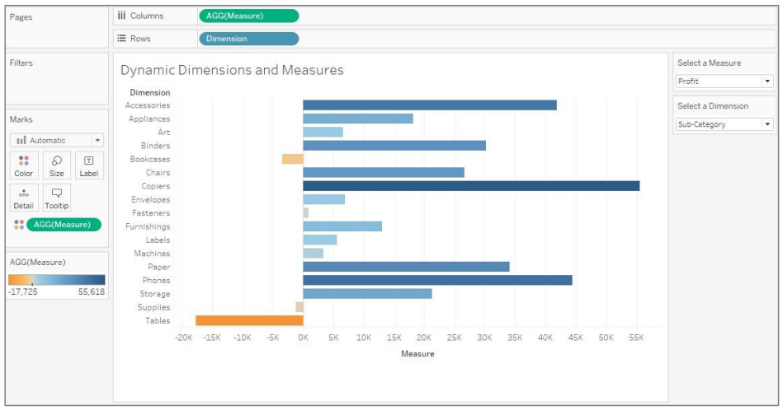

**Detailed Instructions:**

1. Open **Tableau 10.x** (You can go to Start Menu -> All Programs -> Tableau 10.x).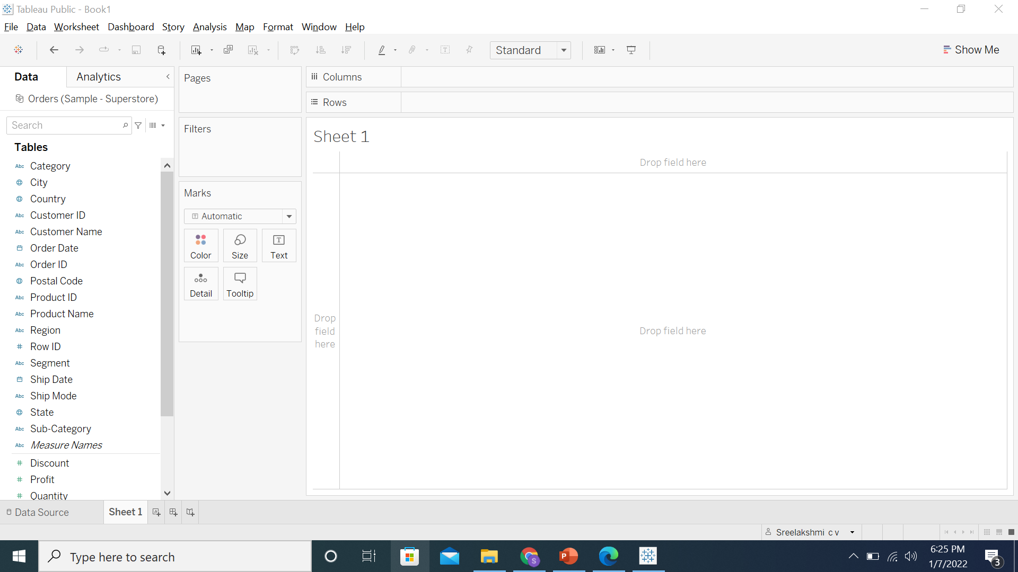
2. From the home page, connect to the saved **Sample – Superstore** dataset

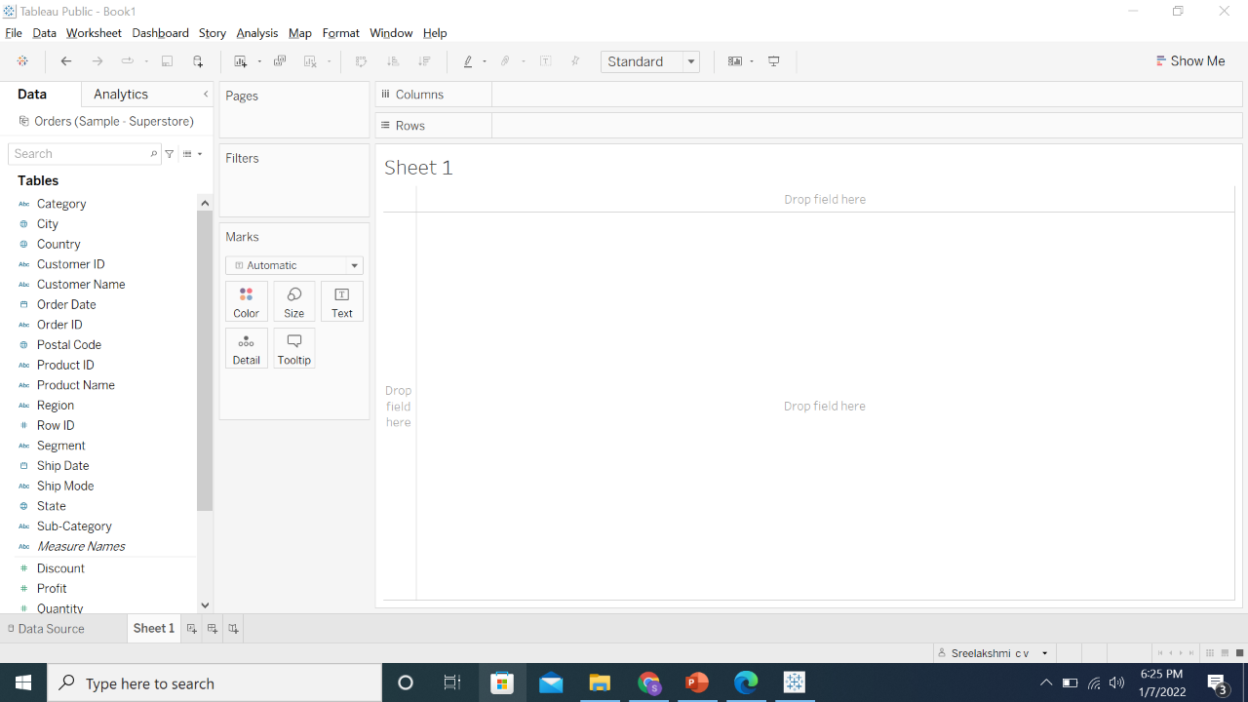

1. Create a parameter called **Select a Dimension**

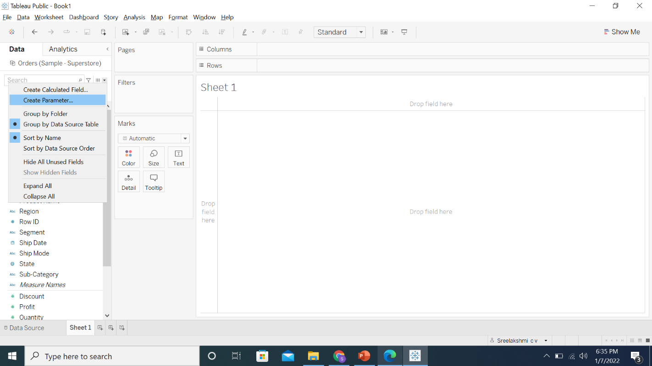

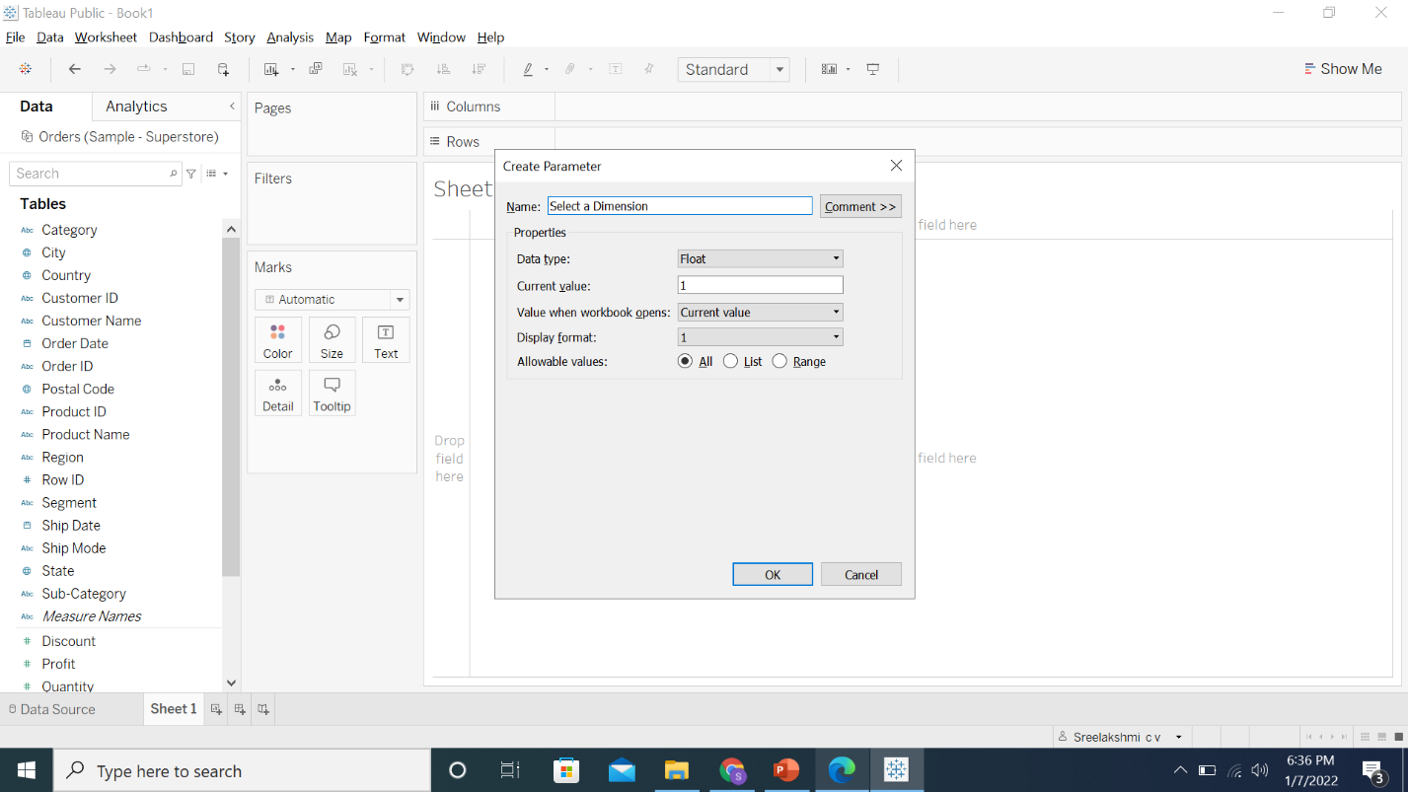

1. In the parameter editor, select the Data type as **Integer**

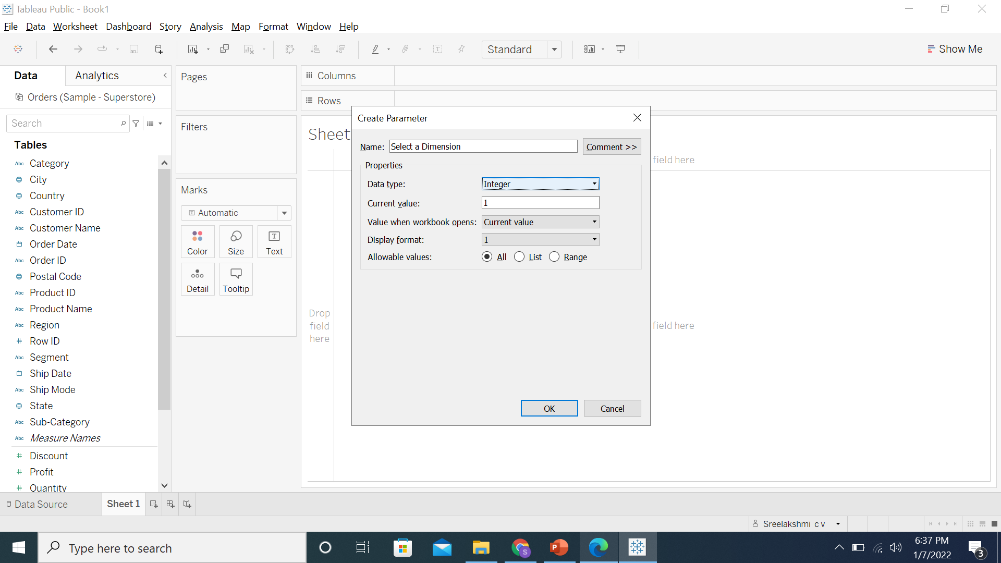

1. Select the **List** radio button

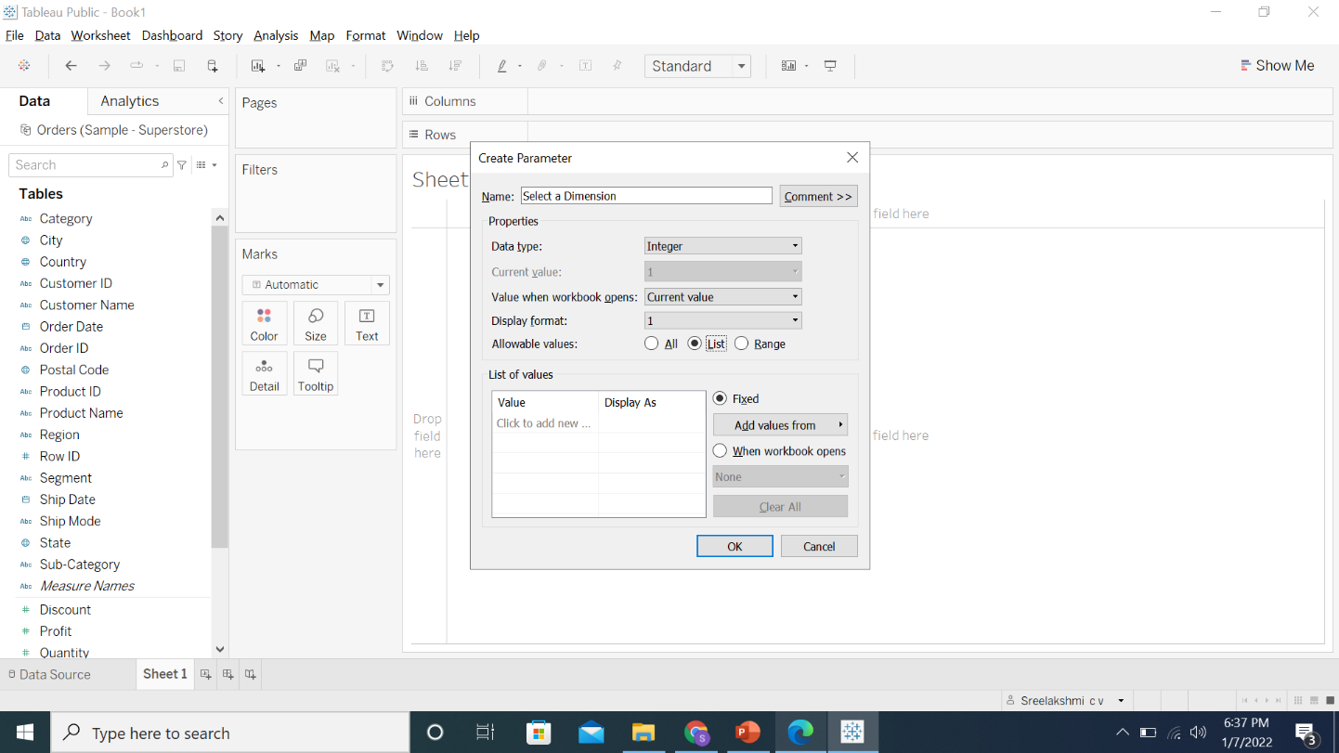

1. Enter the list as below:

**1 Sub-Category**

**2 Region**

**3 Customer Name**

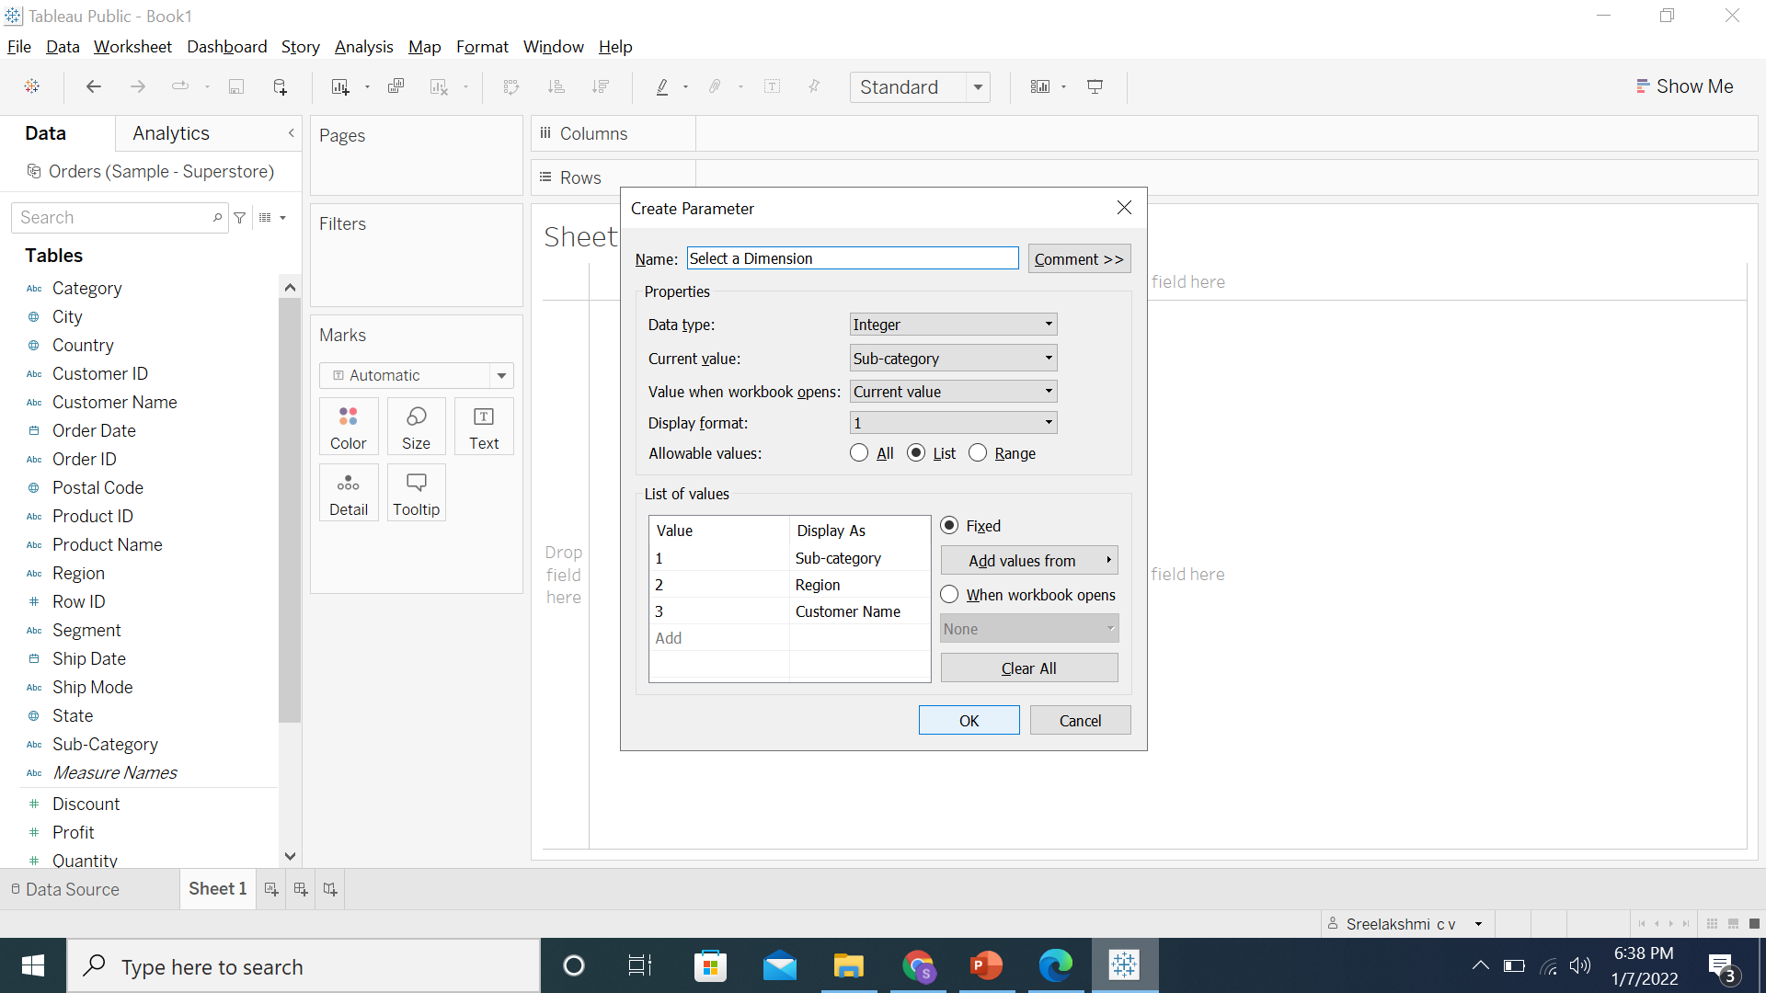

1. Create a calculated field using this parameter

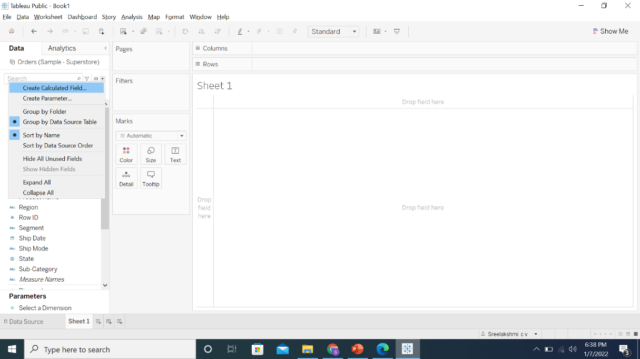

1. Name this calculation **Dimension** and enter the formula below:

**CASE [Select a Dimension]**

**WHEN 1 THEN [Sub-Category]**

**WHEN 2 THEN [Region]**

**ELSE [Customer Name]**

**END**

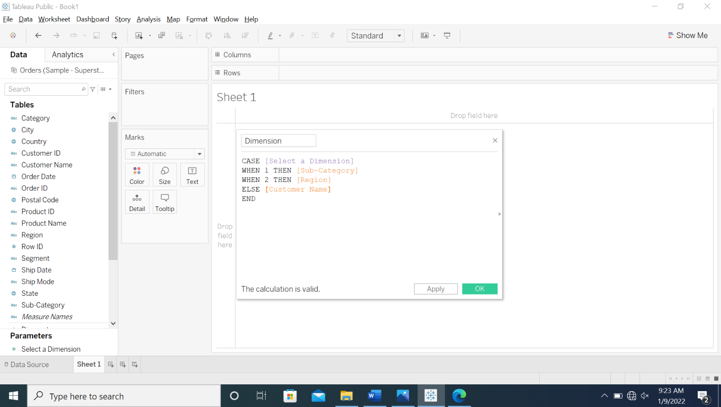

1. Click **OK**

1. To create another parameter, repeat steps 3 to 5. Name this parameter as **Select a Measure**. Ensure that your output looks like the image below

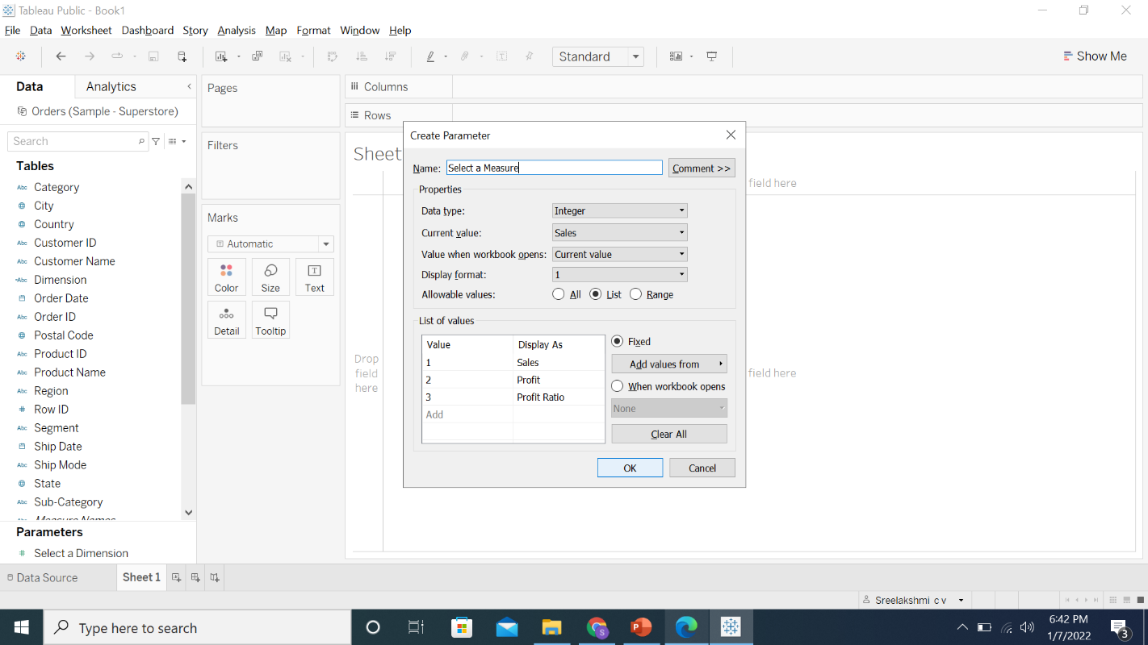

1. Create another calculated field using this parameter

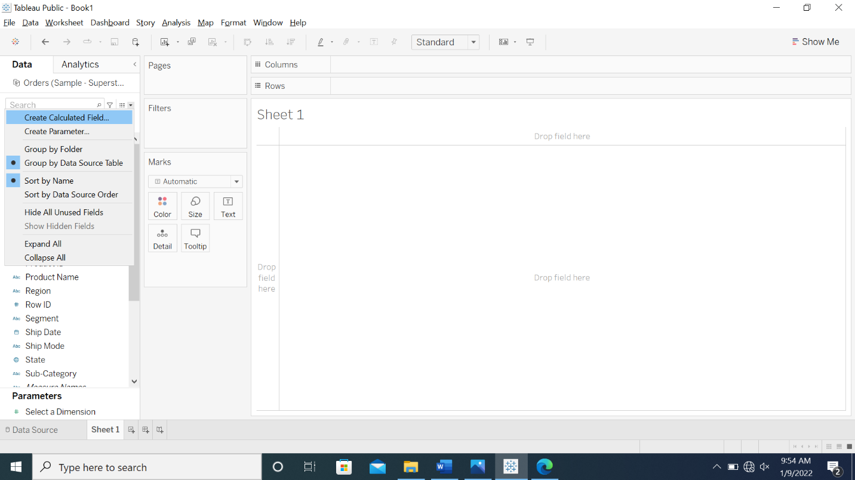

1. Name this calculation **Measure** and enter the formula below:

**CASE [Select a Measure]**

**WHEN 1 THEN SUM([Sales])**

**WHEN 2 THEN SUM([Profit])**

**ELSE [Profit Ratio]**

**END**

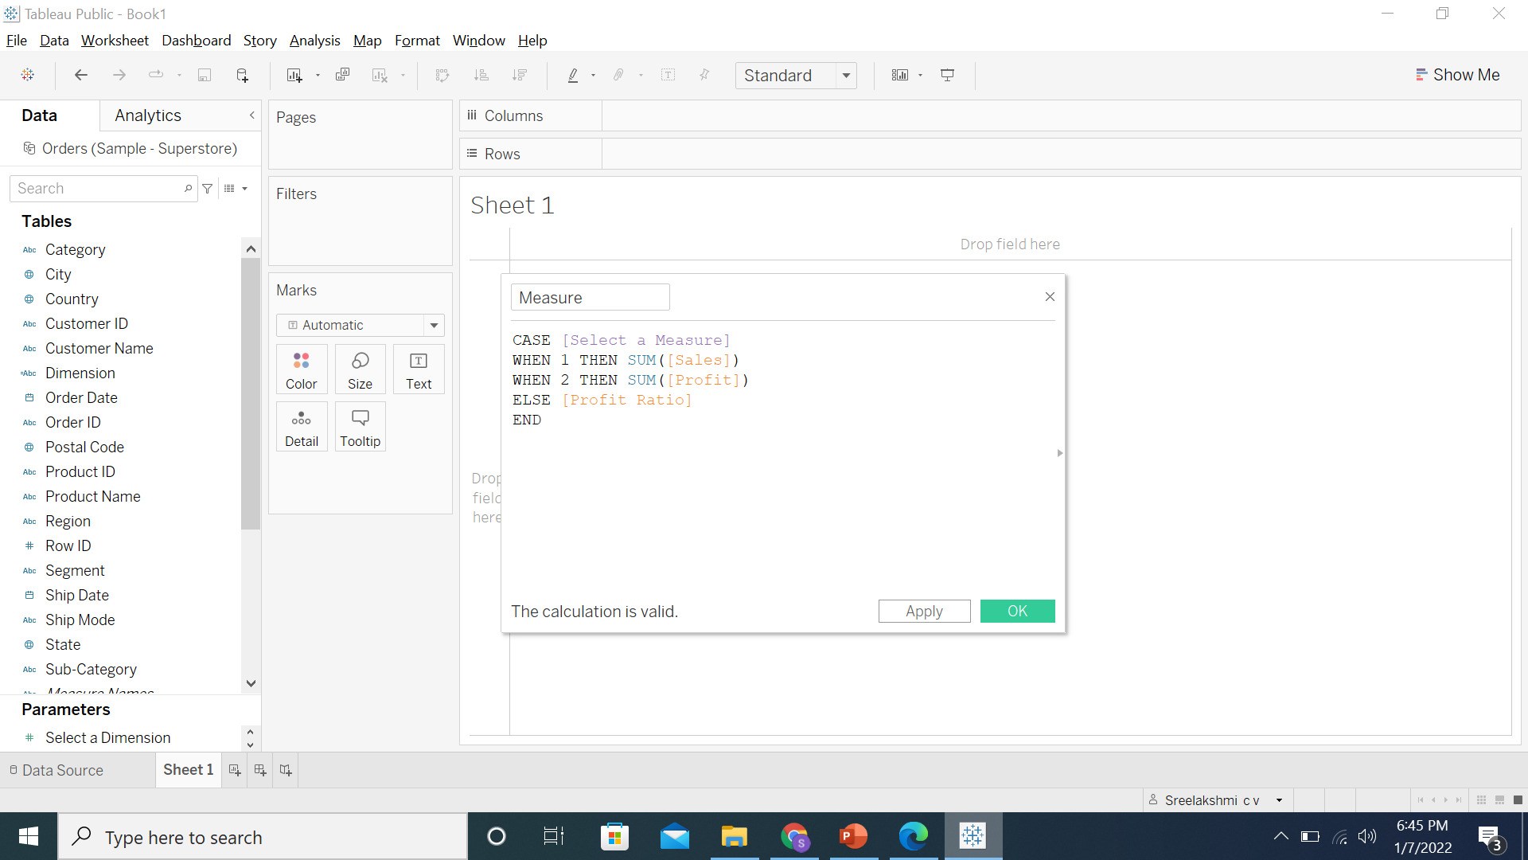

1. Click **OK**



1. To create a view, drag the **Dimension** calculated field to **Rows** and **Measure** to **Columns**

1. To show parameter control, right-click the parameters and select **Show Parameter**

15.1. Right-click on **Select a Measure** and select **Show Parameter**

15.2. Right-click on **Select a Dimension** and select **Show Parameter**

1. To color the marks, drag the **Measure** calculated field to **Color**

1. Rename the sheet as **Dynamic Dimensions and Measures**

1. Save the workbook as **Lesson 9 - Exercise**

**Answers**

Based on the view, these are the answers to the questions in the problem statement:

* Which Sub-Category has the lowest profit?

Answer: **Tables**

* Which Customer has generated the highest sales?

Answer: **Sean Miller**